

**Tribhuvan University**

**Faculties of Humanities and Social Sciences**

**Scholarship Management System**

**Mid-defence Project**

**Submitted to**

**Department of Computer Application**

**Ratna Rajyalaxmi Campus**

**Pradarshani-marga, Kathmandu**

***In partial fulfilment of the requirements for the Bachelors in Computer Application***

**Submitted by**

Aashutosh khadka (6-2-40-1-2021)

Akash Bhandari (6-2-40-3-2021)

**Under the Supervision of Mr. Aananda K.C**

March, 2024



**Tribhuvan University**

**Faculties of Humanities and Social Sciences**

**Supervisor’s Recimmendation**

I hereby recommend that this project prepared under my supervision by **Aashutosh Khadka** and **Akash Bhandari** entitled “**Scholarship Management System** ” in partial fulfilment of the requirements for the degree of Bachelor of Computer Application is recommended for the final evaluation.

**______________________**

**Mr. Aananda K.C**

**SUPERVISOR**

**Department of Computer Application**

**Pradarshani Marg, Kathmandu**

# ACKNOWLEDGEMENT

The project work presented in this report has been carried out and presented at Ratna Rajya Laxmi Campus, Faculty of Humanities and Social Sciences Tribhuvan University of Technology as a part of Bachelors of Arts in Computer Application. Project is a test of not only technical skills but also team work and performance under various constraints. This journey cannot be successfully accomplished without help from experts.

Furthermore, we would like to thank our lecturers of the Department of Computer Application for their kindness in sharing their knowledge with us which in different ways has helped us in coming up with this project and being there for us when we needed them, our friends who have always been there to support us and our respondents who gave us feedbacks on improving our project work.

We will be ever grateful to our supervisor **Mr. Aananda K.C**, Lecturer without whose guidance, this project would not have become successful.

We are also grateful to our department coordinator **Mr. Bhupendra Ram Luhar**.

Finally, our greatest appreciation and love goes to our families, friends and mentors and for sure this would not have happened without their unconditional love, care and support.

# ABSTRACT

Scholarship Management System is an online, web-based solution designed to digitize and streamline scholarship management and administration processes. It aims to bridge the gap between applicants and scholarship organizations, providing a common platform for students to easily discover and apply for scholarships. Digitizing manual tasks such as application tracking and award processing enhances efficiency and reduces administrative burdens for organizations of all sizes. Furthermore, it ensures compliance with regulations, reduces fraud risk, and provides detailed reports on applicants and recipients. The system's main focus is to provide deserving students with access to education opportunities they might not otherwise afford, motivating academic excellence and career advancement. It provides a user-friendly interface, personalized support, and resources for applicants, as well as assisting organizations in improving their scholarship offerings. Overall, the system's well-defined workflow facilitates the administration of scholarship programs, saving time, improving accuracy, and providing recipients with better support.

Contents

ACKNOWLEDGEMENT 3

ABSTRACT 4

Introduction 1

Problem Statement 2

Objectives 3

Requirement Analysis 4

Functional Requirements. 4

System Use Case Diagram 5

Non- Functional Requirements. 6

High level Design of system 7

ER-Diagram 7

Level 0 DFD 8

Level 1 DFD 8

System Developing Tools 9

Implementation tools 9

Implementation Details of Modules 10

Testing 11

Test Case for Unit Testing 11

Excepted Outcome 12

# 

# Introduction

Scholarship Management System is designed to help organisations manage and administer scholarships. This is an online web-based system that looks to digitise the process of awarding scholarships, tracking recipient information, and providing students with personalised support and resources. Scholarships saves you from debt any students graduate from college with huge loan debts. Scholarship Gives you a career advantage and earning a scholarship is prestigious. This system helps to bridge the gap between applicants and scholarship organisations which helps applicants easily find and apply for scholarships. This system is a digital approach to making all the scholarships available in different universities to students on a common platform. This will not only make the discoverability of the scholarships easier, but also make the whole process transparent and fair.

This management system is tailored to the needs of any organisations, large or small, and it is designed to streamline the scholarship process to make it as smooth and easy as possible. It automates many manual tasks, such as tracking applications and processing awards, making it easier to administer scholarships. The system also helps organisations to ensure compliance with regulations and provide detailed reports of applicant and recipient information. It also reduces the risk of frauds. The main focus of the Scholarship Management System is to provide awards and Scholarships to students deserving to have education that might otherwise be beyond their reach and to encourage them to study well and to motivate the students to perform even better.

The system provides the necessary information on how the organisation can improve its scholarship offerings based on a sorting system. And this system is user friendly and provides all the necessary information about the various scholarship programs available and also provides support to those who have difficulty in applying for scholarships. Additionally, it helps organisations to better track the success of their scholarship programs, saving time, improving accuracy, and providing better support to recipients. The system has a well-defined workflow that helps in the complete administration of the scholarship programs.

# Problem Statement

In the context of Nepal, many organisations have to face different problems in order to provide scholarships to different people and as organisations cannot verify applicants are either deserving or not, so due to this applicant does not get proper information about scholarship. And also, people are very busy as they do not have time to visit organisations or fields and know the details of scholarships from different organisations.

People from different countries are finding difficulties with the process of applying for scholarships and are so far away from even visiting the organisation to apply for the scholarship programs. And finding the deserving applicants is also a main problem as there isn’t any proper way to broadcast the available scholarships programs. This makes it difficult for the people in need of financial aid to access scholarships and makes it difficult for organisations to find potential applicants.

# Objectives

The objective of the Scholarship Management System is to overcome these issues, creating an online system where they can easily advertise their scholarship programs and provide all necessary information. This will also help applicants to easily apply for scholarships from any location. This will make it easy for people who are in need of financial aid to access scholarships and make it easy for organisations to find potential applicants.

* This System/Website provides a comprehensive source of information about scholarships, including eligibility requirements and the application process.
* The platform provides for individuals to connect with organisations and apply for scholarships online.
* The platform is user friendly; it supports those who have difficulty in applying for scholarships.
* The platform is designed to help organisations manage and administer scholarships. It helps to automate the process of awarding scholarships, tracking recipient information, and providing students with personalised support and resources.
* This platform connects students with scholarship providers and provides all the necessary information about the available scholarship and makes it more accessible for the students.

Thus, it is an important system that connects people in need with organisations offering scholarships. Furthermore, it provides support and guidance to students to help them apply for the scholarships.

# Requirement Analysis

For this system, requirements are basically identified through functional and non-functional requirements.

## Functional Requirements.

**For Applicants:**

* The system allows applicants to register.
* The system allows applicants to apply for Scholarship Programs.
* The system displays categories for applicants to apply.
* The system keeps records for applicants to apply multiple programs from same account.

**For System Administrator:**

* The system allows system administrator to login and logout from the system.
* The system creates and manage all username and password.
* The system allows Admin to provide award and scholarships.
* The system allows the system administrator to manage details and information of applicants.
* The system allows the system administrator to update information of the applicants.
* The system allows monitoring the system users data.

## System Use Case Diagram

The System Use Case Diagram is shown as follow:

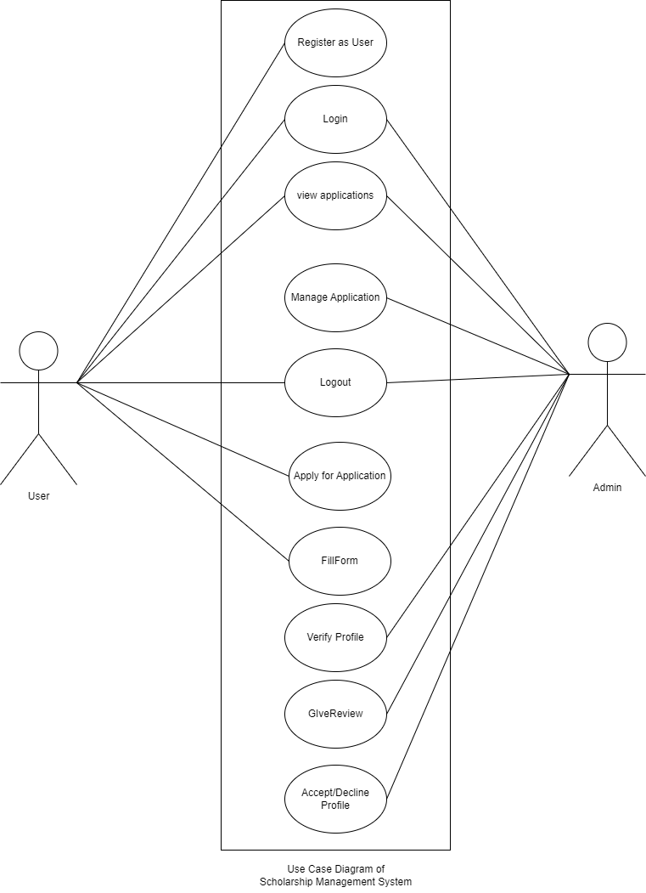

#### Figure 1: Use Case Diagram for Scholarship Management System

## Non- Functional Requirements.

**Security**

Admin representatives on duty will be able to log into the system and have access to the scholarship system but access to various subsystems will be protected by the user login screen that requires a username and password.

**Availability**

The system will be available for 24 hours service as users can apply from anywhere and at any time. The performance of the system will be fast and accurate as it will provide fast response to the user’s actions. The system will handle expected and unexpected errors and also large amounts of data.

**Reliability**

The system will be reliable as it will perform function and run without a failure and it has to be reliable due to the importance of data and damages that can be caused by incorrect or incomplete data. [4]

# **High level Design of system**

## ER-Diagram

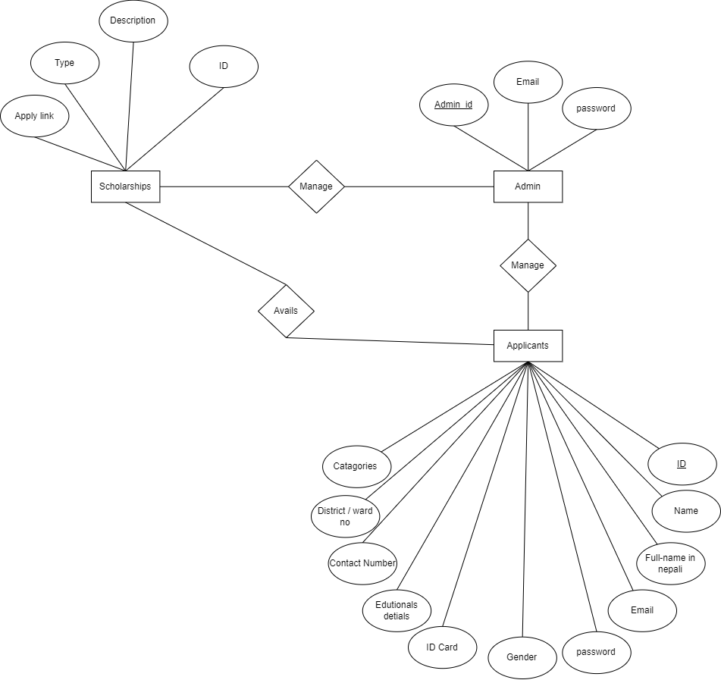

#### Figure 2: ER-Diagram for Scholarship Management System

## Level 0 DFD

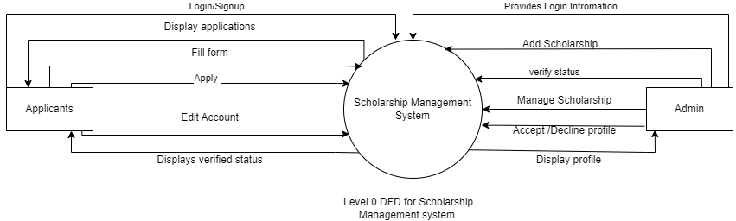

#### Figure 3: Level 0 DFD for Scholarship Management System

## Level 1 DFD

#### Figure 4: Level 1 DFD for Scholarship Management System

# Interface Design

### Homepage:

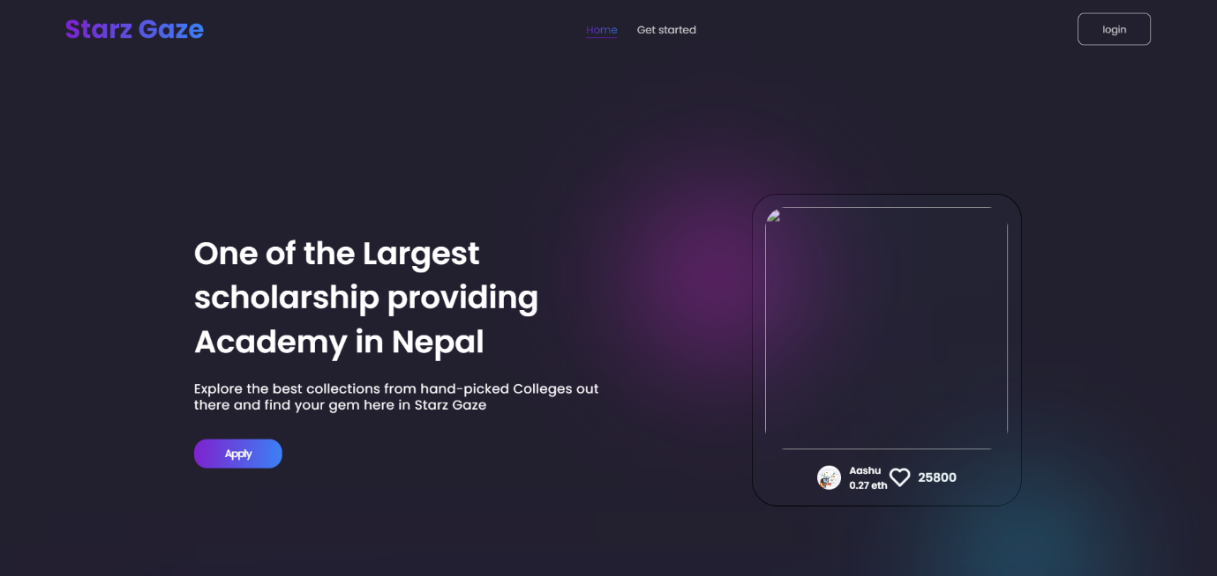

### Registration page:

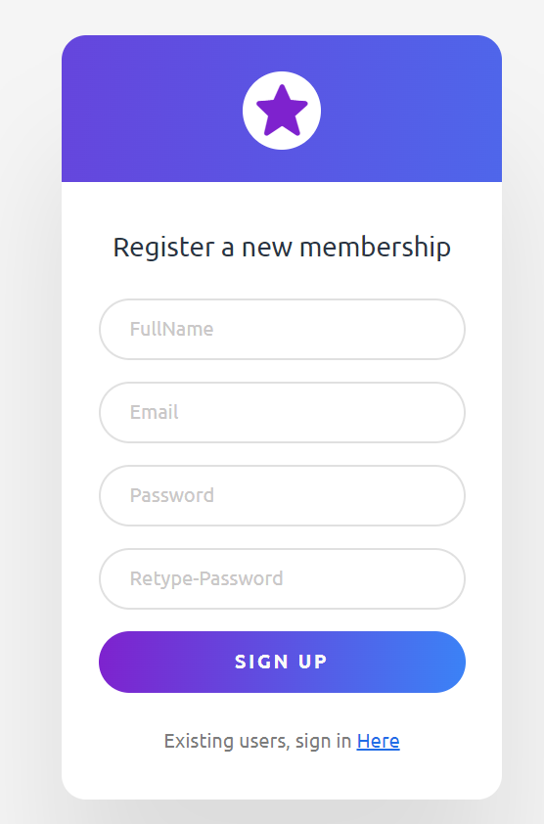

### Sign in page:

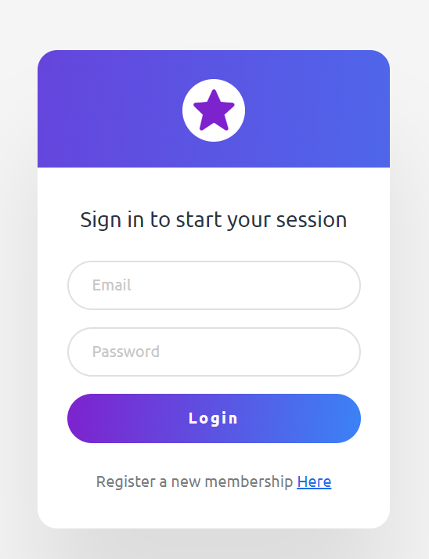

# 

# System Developing Tools

### Implementation tools

#### Diagram Tool:

The designs used in this project are all made with help of “draw.io”. It is an online diagramming tool that allows to create various types of diagram and charts. It has a wide range of prebuilt shapes and icons that can be used to create custom layout and design. The tool also offers drag-and-drop interface.

**HTML:**

HTML (Hypertext Markup Language) is a standard markup language used for creating and structuring the content of web pages. HTML has been used to design the frontend of webpages.

**CSS:**

CSS (Cascading Style Sheets) is a style sheet language used to describe the presentation and formatting of HTML (and XML) documents. The styling to the web page is done using CSS.

**PHP:**

PHP (Hypertext Preprocessor) is a popular server-side scripting language. It is used for building dynamic websites and web applications.

**MySQL:**

MySQL is an open-source relational database management system used for storing and managing structured data. It is based on the structured query language. With the help of MySQL, we can perform CRUD operations.

**Visual Studio Code:**

Visual Studio Code is a source code editor. Different programming language are readily available thus making the coding process faster and hassle free.

# Implementation Details of Modules

**User Registration:**

Users have to register into the system before they login into the system. User is required to fill the registration from with text boxes.

**Apply for scholarship:**

User logged in into the system can Apply for Scholarship application.

**Add scholarships:**

Admin can upload Scholarships with scholarship title, valid time and status.

**Validation:**

Admin can verify and validated the user’s information.

**User Logout:**

User can logout of the system as per their choice.

## Testing

The testing is performed to verify and validate the Online Music Streaming Platform. The presented system is tested to see if it is working properly with no error and if it fulfils the necessary requirement.

## Test Case for Unit Testing

It is performed to determine if there are any issues and its main aim is to identify, analyze and fix the found defects.

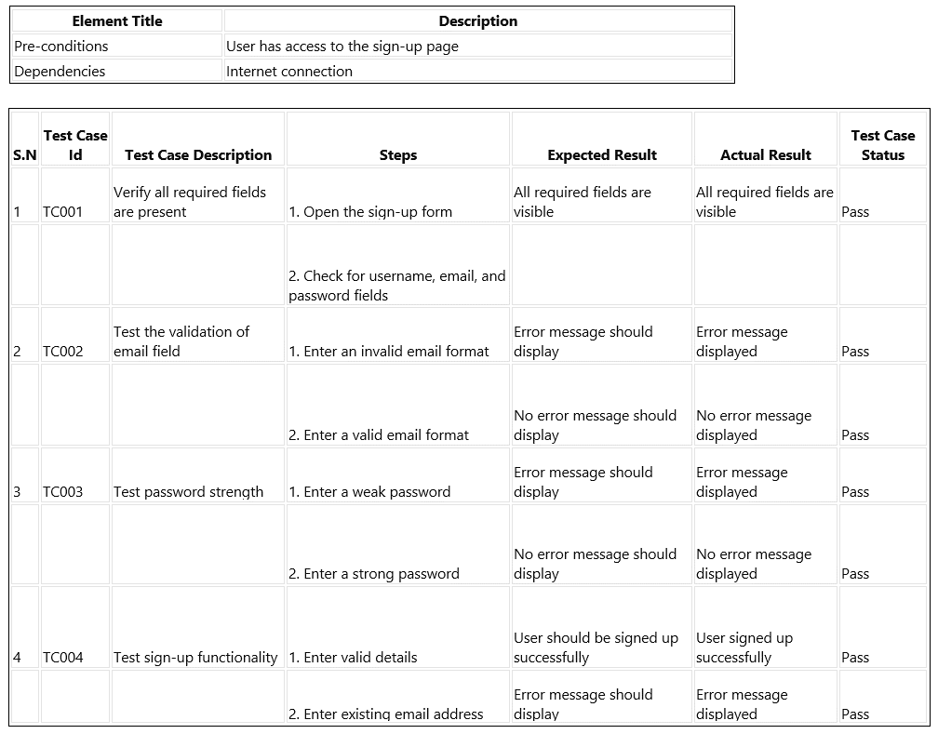**Testing Sign Up:**

# Conclusion

The Scholarship Management System presented in this project offers a comprehensive solution to streamline the process of managing and administering scholarships. By digitizing manual tasks and providing a user-friendly platform, the system aims to bridge the gap between applicants and scholarship organizations, making it easier for deserving students to access education opportunities.

Through careful requirement analysis, the system's functional and non-functional requirements were identified, ensuring that it meets the needs of both applicants and system administrators. Functional requirements include features such as user registration, scholarship application, and system administration capabilities, while non-functional requirements address aspects like security, availability, and reliability.

The system's high-level design, including the ER diagram and data flow diagrams, provides a visual representation of its structure and functionality. Implementation details outline the tools and technologies used to develop the system, including HTML, CSS, PHP, MySQL, and Visual Studio Code.

Testing was conducted to verify the functionality and performance of the system, ensuring that it operates smoothly and without errors. Unit testing, in particular, helped identify and address any defects present in the system.

Overall, the Scholarship Management System offers a robust solution to the challenges faced by organizations and applicants in managing and accessing scholarship opportunities. By providing a centralized platform for scholarship management, the system promotes transparency, fairness, and accessibility, ultimately facilitating academic excellence and career advancement for deserving students.